

**ADDIS ABABA INSTITUTE OF TECHNOLOGY**

**CENTER OF INFORMATION TECHNOLOGY AND SCIENTIFIC COMPUTING**

**DEPARTMENT OF** **SOFTWARE ENGINEERING**

Introduction to web and WWW

Submitted To: Mr. Fitsum Alemu

February 28, 2020

**The History of internet.**

What is internet

The internet is a network of computers or we can say network of networks linking many different types of computers all over the world. Or we can define internet as a global computer network providing a variety of information and communication facilities, consisting of interconnected networks using standardized communication protocols.

The evolution of internet.

The internet was first introduced the US Army in the Pentagon's Defense Department of America. During the Cold War, it was essential to have communication links between military and university computers that would not be disrupted by bombs or enemy attacks. In order to solve the problem, in 1968 (about) DARPA (Defense Advanced Research Projects Agency) made contracts with BBN (Bolt, Bernanke and Newman) to create ARPANET (Advanced Research Projects Agency Network). Then ARPAnet became the first networking project which was use in war for transforming confidential instruction.

Bob Kahn came over to ARPA from BBN in 1972. He started working on expanding Arpanet’s capabilities for the military, thinking about wireless networking via. packet radio, and networking via. satellite. He tried to think about how the network’s protocol should be expanded from an engineering perspective, to accommodate the other uses he was thinking about (wireless and satellite, and any others that hadn’t been thought about yet).

ARPAnet used the ARPA network. The ARPA network originally used NCP (Network Control Protocol), but as time progressed, the ARPA network adapted a new protocol called TCP/IP (Transmission Control Protocol/ Internet Protocol) in the year 1983. Three working groups were set up to create the first TCP/IP implementations. These implementations were completed in 1975. Then one of the most important events that happened in the 1990s was the invention of the World Wide Web (WWW). The first Web was started in November 1990 by Tim Berners-Lee at CERN. With the start of WWW and browsers start to surf the Internet.

2.View the 5 – 10 popular websites of your choice from web archive URL and put your observation and assessment

Web design has come a long way since the days of plain white pages and lists of blue links. In the last twenty years, it has evolved in ways most people who were around during the infancy of the World Wide Web could have never imagined. we’re presenting an overview of some websites by dividing at the start, some years later and know.

1. Google:

## Google has its origin in 1996 by Larry Page and Sergey Brine. as it created it contain like Poor or dated visual design, Low standard of written content, Hidden details or no obvious point of contact. But later modifications are added to the website and it became good compared to the first one. When we some years later in 2006 it avoids some of the problems which are found in google. But at this time also it has some lacks and problems. As HTML5 and CSS3 have advanced components but they are not developed at that time.

## C:\Users\miko miko\Pictures\Screenshots\Screenshot (3).png

Nowadays google has become more advanced using Further innovations in technologies like HTML5, CSS3, and JavaScript have enabled and it became more advanced and complex website than before further emphasized by the addition of mobile and apps.

1. YouTube:

YouTube was first introduced in 2005. As it introduced in to the web it is not interesting and attractive because at that time most advanced forms of html and css are not take place.

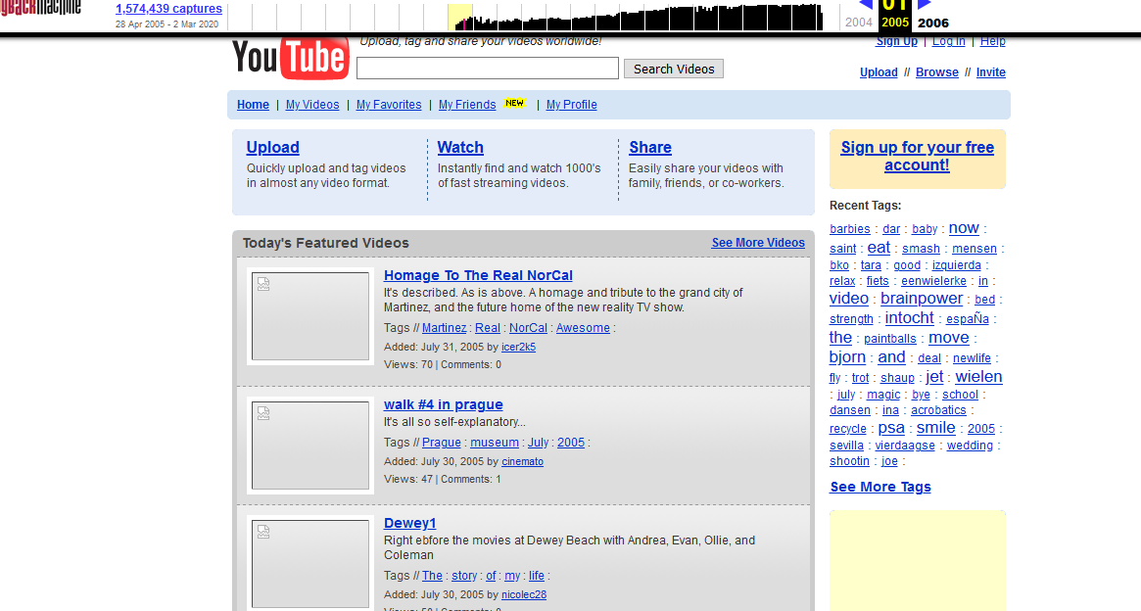

Figure 1 YouTube in July 2005

## As we see in the above image it seems totally different from the present YouTube website. It lacks organization and beauty. The contents are compacted.

If we see after 10 years in 2015, it gets some modifications and it seems more attractive and organized. It has best JavaScript usage and also web 2.0 come in to practice, While the term “web 2.0” might be unclear, it may be used to refer to the growth of multimedia applications, interactive content, and the introduction of social media platforms. All of these features started to gain prominence from around 2005 and onwards, and marked the definitive death of Flash.

But know YouTube has become one of the most used website in the world. Further innovations in technologies like HTML5, CSS3, and JavaScript have enabled YouTube to become more advanced and complex website than before.

## mit

The late 90s introduced a new innovation: Flash. Growing impatient with the lack of support for animation and video on the web, Macromedia attempted to hijack the web with the introduction of Flash technology.

The early 2000s saw the influx of CSS, enabling the separation of content and design. To see what we mean, visit [CSS Zen Garden](http://www.csszengarden.com/) and view the same content in different designs.

Content could be created independently of design, and vice versa, making websites easier to maintain with less code and complexity.

While the term “web 2.0” might be unclear, it may be used to refer to the growth of multimedia applications, interactive content, and the introduction of social media platforms. All of these features started to gain prominence from around 2005 and onwards, and marked the definitive death of Flash.

“Web 2.0” introduced more JavaScript functionality in the web browser, as well as Ajax technology—which downloads and refreshes parts of a website. Now the web went from being static HTML to function more like the web we’re familiar with today. Greater attention were paid to typography, whitespace, colour palette, user experience, and SEO. 2005 also saw the launch of YouTube:

Further innovations in technologies like HTML5, CSS3, and JavaScript have enabled more advanced and complex websites than before—further emphasised by the addition of mobile and apps.

At the same time more awareness about UX, content strategies, and [SEO](https://enonic.com/blog/increase-website-visibility-seo-meta-fields-app) have made their marks as well, resulting in web pages with minimalist graphics, flat design, blended typography, large [images](https://enonic.com/blog/top-5-image-handling-issues-cms), and single-page structures.

3) List 5 website each on the 12 categories you learned

* + Try to view their look in different years’ web archives

Advocacy Websites.

* it is to promote or reinforce a change in policy, program or legislation

1. MoveOn.Org [[http://www.moveon.org](http://www.moveon.org/)/]
2. Security on Campus <http://www.campussafety.org/>
3. World Wildlife Fund <http://www.panda.org/>
4. Stand for Children <http://www.stand.org/>
5. Freedom Forum <http://www.freedomforum.org/>

Portal websites.

1) disability.org <http://www.disability.org/>

3) india.gov.im https://www.india.gov.im/

3) Addis Ababa university https:// www.aau.edu.et

4) national resource directory https://nrd.gov/

5) australia.gov.au https://www.australia.gov.au/

News:

1. CNN <https://edition.cnn.com/>
2. BBC <https://www.bbc.com/>
3. New York Times <https://www.nytimes.com/>
4. Daily Sun <https://www.dailysun.co.za/>
5. Fox News <https://www.foxnews.com/>

Business/marketing websites

1) Alexander real estate https://www.alexanderealestate.com/

2) Anderson Wise Architects <https://www.anderssonwise.com/>

3) Gumption <https://www.shopgumption.com/>

4) Gogoro <https://www.gogoro.com/>

5) World Financial Group <http://worldfinancialgroup.com/>

Social Network

1. Facebook https://www.facebook.com/
2. Telegram https://www.telegram.com/
3. Twitter https://www.Twitter.com/
4. Instagram https://www.Instagram.com/
5. WhatsApp <https://www.whatsap.com/>

Wiki

1. Gamepedia https://www.gamepedia.com/
2. Wikipedia https://www.wikipedia.org/
3. Wikitionary https://www.wiktionary.org/
4. Conservapedia https://www.conservapedia.com/
5. Everypedia <https://everipedia.org/>

Content aggregator:

websites that are certainly something that you’ve run into at least a few times in your life on the web. But when it comes time to think about examples of content aggregator websites, your mind might be going blank.

1. Popurls <http://m.popurls.com/>
2. WP news Desk <http://wpnewsdesk.com/>
3. Freedly <https://feedly.com/>
4. Pocket <https://getpocket.com/>
5. Blog Engage <http://www.blogengage.com/>

Informational website

1. Mentalfloss.com https://www.mentalfloss.com/
2. Mashable https://mashable.com/
3. Trip Advisor https://www.trip.com
4. Cisco https://www.cisco.com
5. MIT course ware https://ocw.mit.edu/courses/

Entertainment

#### Bare Feet <https://www.travelbarefeet.com/>

#### Tobias Meinhart <https://tobiasmeinhart.com/>

#### Vinegar Hill <https://vinegarhill.co.uk/>

#### Vineyard Music and Events <https://www.vineyardworship.com/>

#### Korekayu <https://korekayu.com/>

Educational

1. Coursera <https://online-learning.harvard.edu/>
2. Big Think <https://bigthink.com/>
3. Khan academy <https://www.khanacademy.org/>
4. CISCO <https://www.cisco.com/>
5. Academia <https://www.academia.edu/>

Blog

1. Microsoft Stories. <https://news.microsoft.com/stories/>

## The Good Trade <https://www.thegoodtrade.com/>

## Hooping heels <http://hoppingheels.com/index.html>

## Sincerely Jules <https://sincerelyjules.com/>

## Fubuzi media <http://www.fubiz.net/en/>

4) What are the guidelines for evaluating the value of a Web site? Try to evaluate 2-5 websites based on the guideline and put your judgment.

**Guidelines for Evaluating Web Sites**

Objectivity.

Objectivity of the site means the website should be clear. sites that contain bias or do not admit its bias freely are not consistent websites. Objective sites present information with a minimum of bias. For example, for Evaluating a marketing or business web site for objectivity we can ask questions like Does the website advertising conflicts with the content? Or Is the site trying to explain, inform, persuade, or sell something?

Technical considerations.

For technical considerations we can verify that the Web site's important capabilities, such as graphics or animations critical to the subject matter, can be utilized with the technology we have available. The page should be stable, that is, consistently available. All the links and special features such as audios must be functioning. If there is a fee for using the site, the site should provide a secure way to send payment.

Content

A site's content should be comprehensible, appropriate, and of value to the intended audience. Awards won by a site may suggest quality but may also be little more than advertising banners for the issuing agencies. There should be enough information to make visiting the site worthwhile. Information on how often the site is visited may indicate its usefulness. That means the site must be logical. And it mustn’t promote social bias.

If there are large amounts of information on the site, there should at least be a site map or outline of topics that allows users to find topics and move among them easily. A search function for locating information within the site would also be useful. The information should be accurate and updated.

Authority

Authority reveals that the person, institution or agency responsible for a site has the qualifications and knowledge to do so. For evaluating a web site for authority means that a website:

* Contact information should be clearly provided: e-mail address, phone number, and fax number
* should be clear who developed the site.
* Credentials that the author should state the qualifications, credentials or personal background that gives them authority to present information.
* Should be Checked by any user to see if the site supported by an organization or a commercial body

Accuracy

There are few standards to verify the accuracy of information on the web. It is the responsibility of the reader to assess the information presented. Evaluating a web site for accuracy we can see by asking the following criteria’s.

1. References: do statistics and other factual information receive proper references as to their origin?
2. Does the reading you have already done on the subject make the information seem accurate?
3. Is the information comparable to other sites on the same topic?
4. Does the text follow basic rules of grammar, spelling and composition?
5. Is a bibliography or reference list included? And many more other questions can be asked to see the websites accuracy is correct or not.

# **References**

* Evolution of Internet <https://sites.cs.ucsb.edu/> , February 28, 2020
* Lawrence Snyder, Fluency 6 with information technology, April 27, 2019